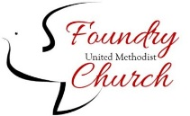**FOUNDRY UMC**

*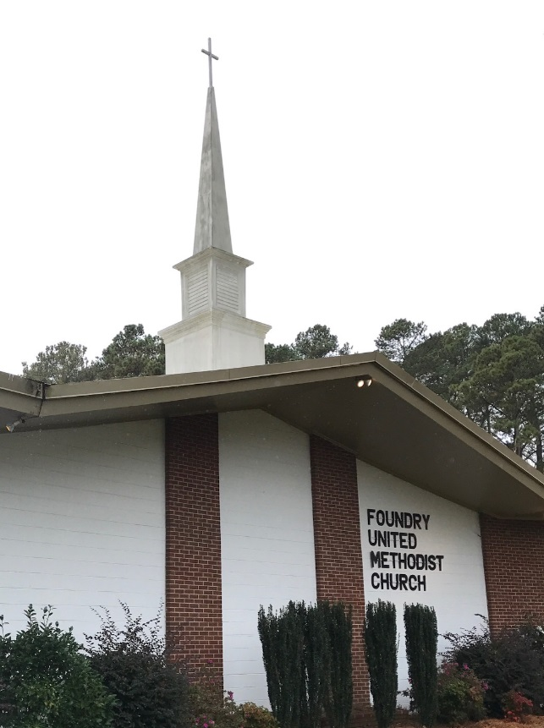Our History*

On January 3, 1958, a four and a half acre land on Virginia Beach Blvd was purchased for $1.00 from Mr. and Mrs Ollie and Adrian Vellekoop.  The property was transferred to the Norfolk District Board of Missions, and the location of Foundry Methodist Church became a reality.  The church was named after the first meeting house of early Methodists in London, where John Wesley had purchased a cannon foundry for his service.

In 1959 members of First Methodist Church in Norfolk pledged their support to the Foundry project and in June of that year the Reverend Douglas G. Ebert was assigned to the proposed church site.

The first service was held in the parsonage on September 13, 1959, with eight persons in attending Sunday School and twenty-two attending the worship service.

On January 3, 1958, a four and a half acre land on Virginia Beach Blvd was purchased for $1.00 from Mr. and Mrs Ollie and Adrian Vellekoop.  The property was transferred to the Norfolk District Board of Missions, and the location of Foundry Methodist Church became a reality.  The church was named after the first meeting house of early Methodists in London, where John Wesley had purchased a cannon foundry for his service.

In 1959 members of First Methodist Church in Norfolk pledged their support to the Foundry project and in June of that year the Reverend Douglas G. Ebert was assigned to the proposed church site.

The first service was held in the parsonage on September 13, 1959, with eight persons in attending Sunday School and twenty-two attending the worship service.